**PURPOSE OF POINT TRACKER:**

Currently Code Ninjas records points earned by ninjas through google sheets.

This method is insecure and unreliable.

Overarching purpose:

The point tracker will fix the problem listed above by making a secure and centralized web application that will allow sensei and ninjas to add/use points.

In the future, this project can be expanded to include daily ninja reports.

**ASPECTS OF THE WEB APPLICATION:**

**Frontend**

The frontend does not use any JavaScript framework and is instead Vanilla JavaScript, HTML, and CSS. Each page is separated into its own unique HTML pages.

Utilizes LocalStorage to store user logins across HTML pages.

The list of pages are:

* Log In
  + Ninjas and Senseis can access.
  + Entry page, first page that loads.
* Check Points
  + Ninjas and Senseis can access.
  + Given a ninja, display the number of points they have.
* Add Points
  + Senseis can access.
  + Given a ninja and given a reason, add to the number of points they have
* Point Store
  + Ninjas can access.
  + Given a ninja and given a reason, deduct the number of points they have
* Point History
  + Ninjas and Senseis can access.
  + Given a ninja, display a list of transaction history. (add points, deduct points)

**Backend**

Passwords are automatically hashed in the frontend and then sent to the back end. This way, if someone were to intercept traffic, passwords would be hashed.

In addition to this, any admin that has access to the database will only have access to the hashes.

This is important because SHA-256 (hashing function) is a one way function.

All Ninja and Sensei data will be put onto a Google Firebase Real-time Database.

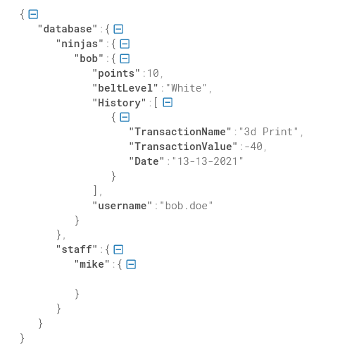

**Features**

* Ninja Log-in
  + Check Points
    - Given a ninja, display the number of points they have
  + Point Shop
    - Given a ninja and given a reason, deduct the number of points they have
  + Point History
    - Given a ninja, display a list of transaction history. (add points, deduct points)
* Sensei Log-in
  + Ninja Search
    - Check Points
      * Given a ninja, display the number of points they have
    - Add Points
      * Given a ninja and given a reason, add to the number of points they have
    - Point History
      * Given a ninja, display a list of transaction history. (add points, deduct points)

**Hosting Details**

The website will be hosted on Firebase Hosting. It is a free and custom hosting solution that offers a free domain but the domain name is not customizable.